NoSQL data assignment 2

1.

Making new database: 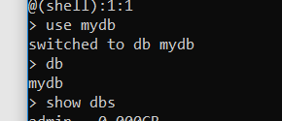

Make collection: 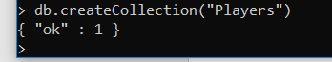

Show collections: 

2.

Inserting player: 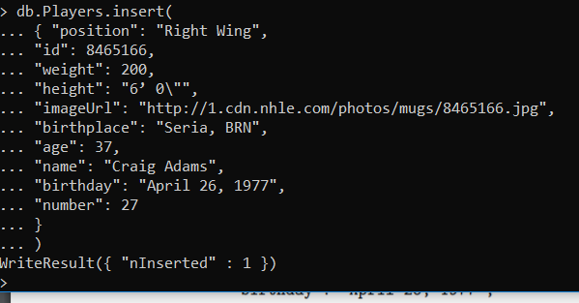

3.

Inserting 3 players: 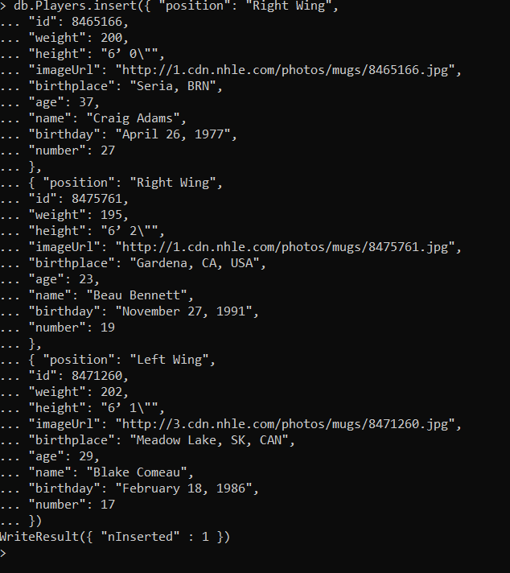

There are 2 of the same people as we have not assigned a primary key for the database.

We can fix it by assigning a primary key;



4.

It error and says the following message:



5.

Removing one Craig: 

Removing the other craigs: 

Removing the collection:

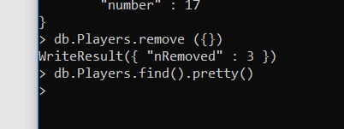

6.

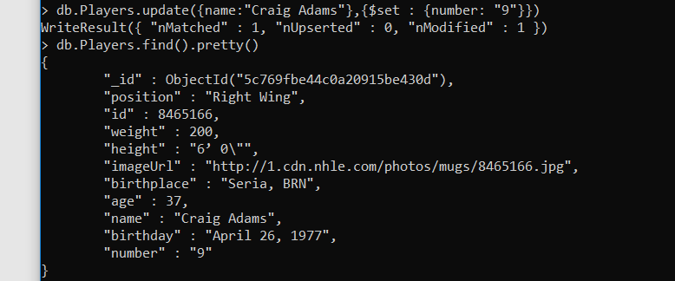

7.

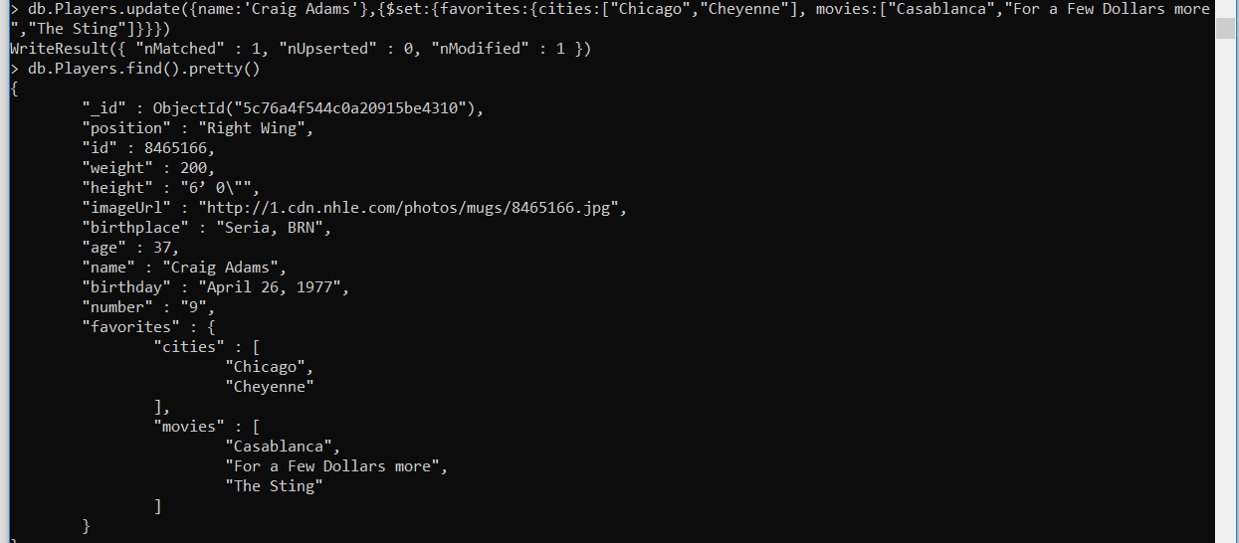

8.

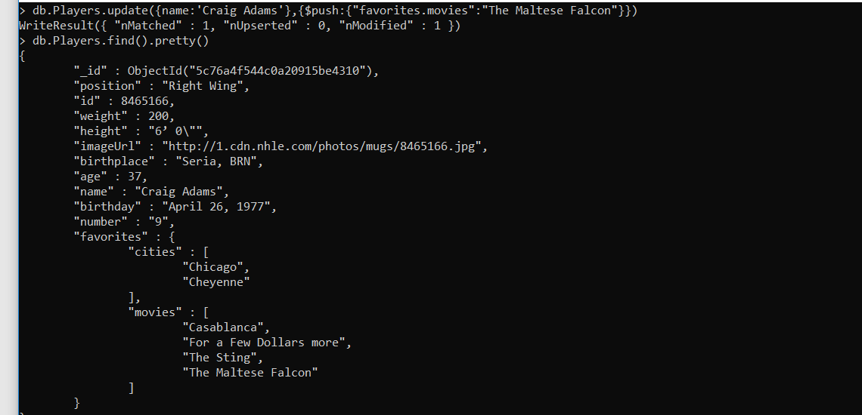

9.

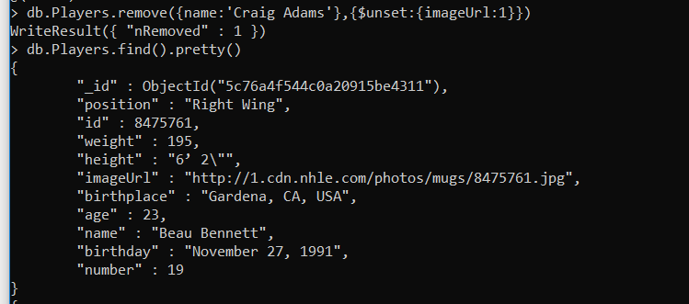

10.



Q2.

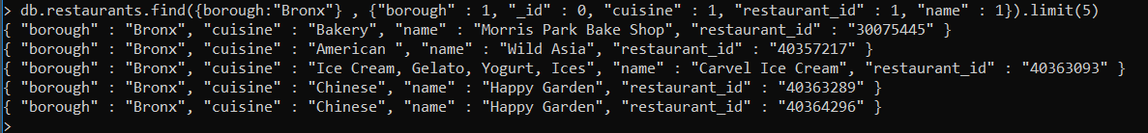

1. 

3.



4.

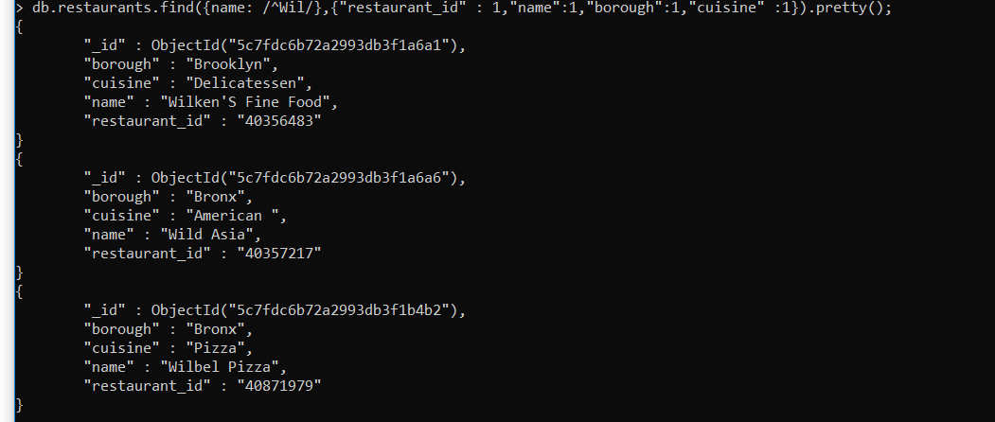

5.

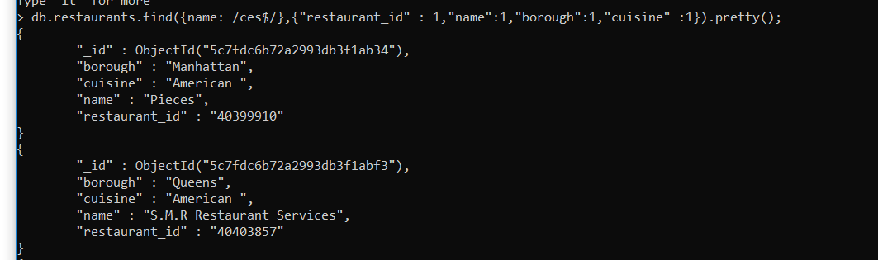

6.

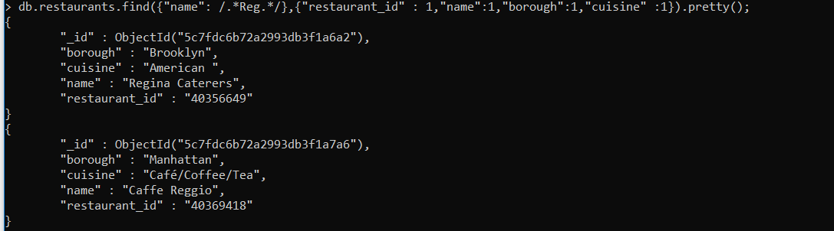

7.

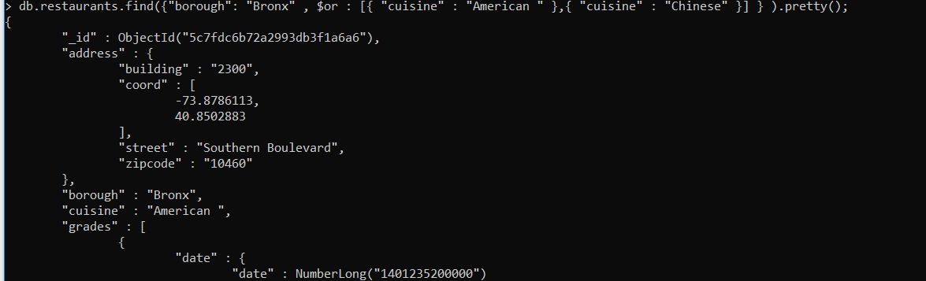

8. 

9. 

10.